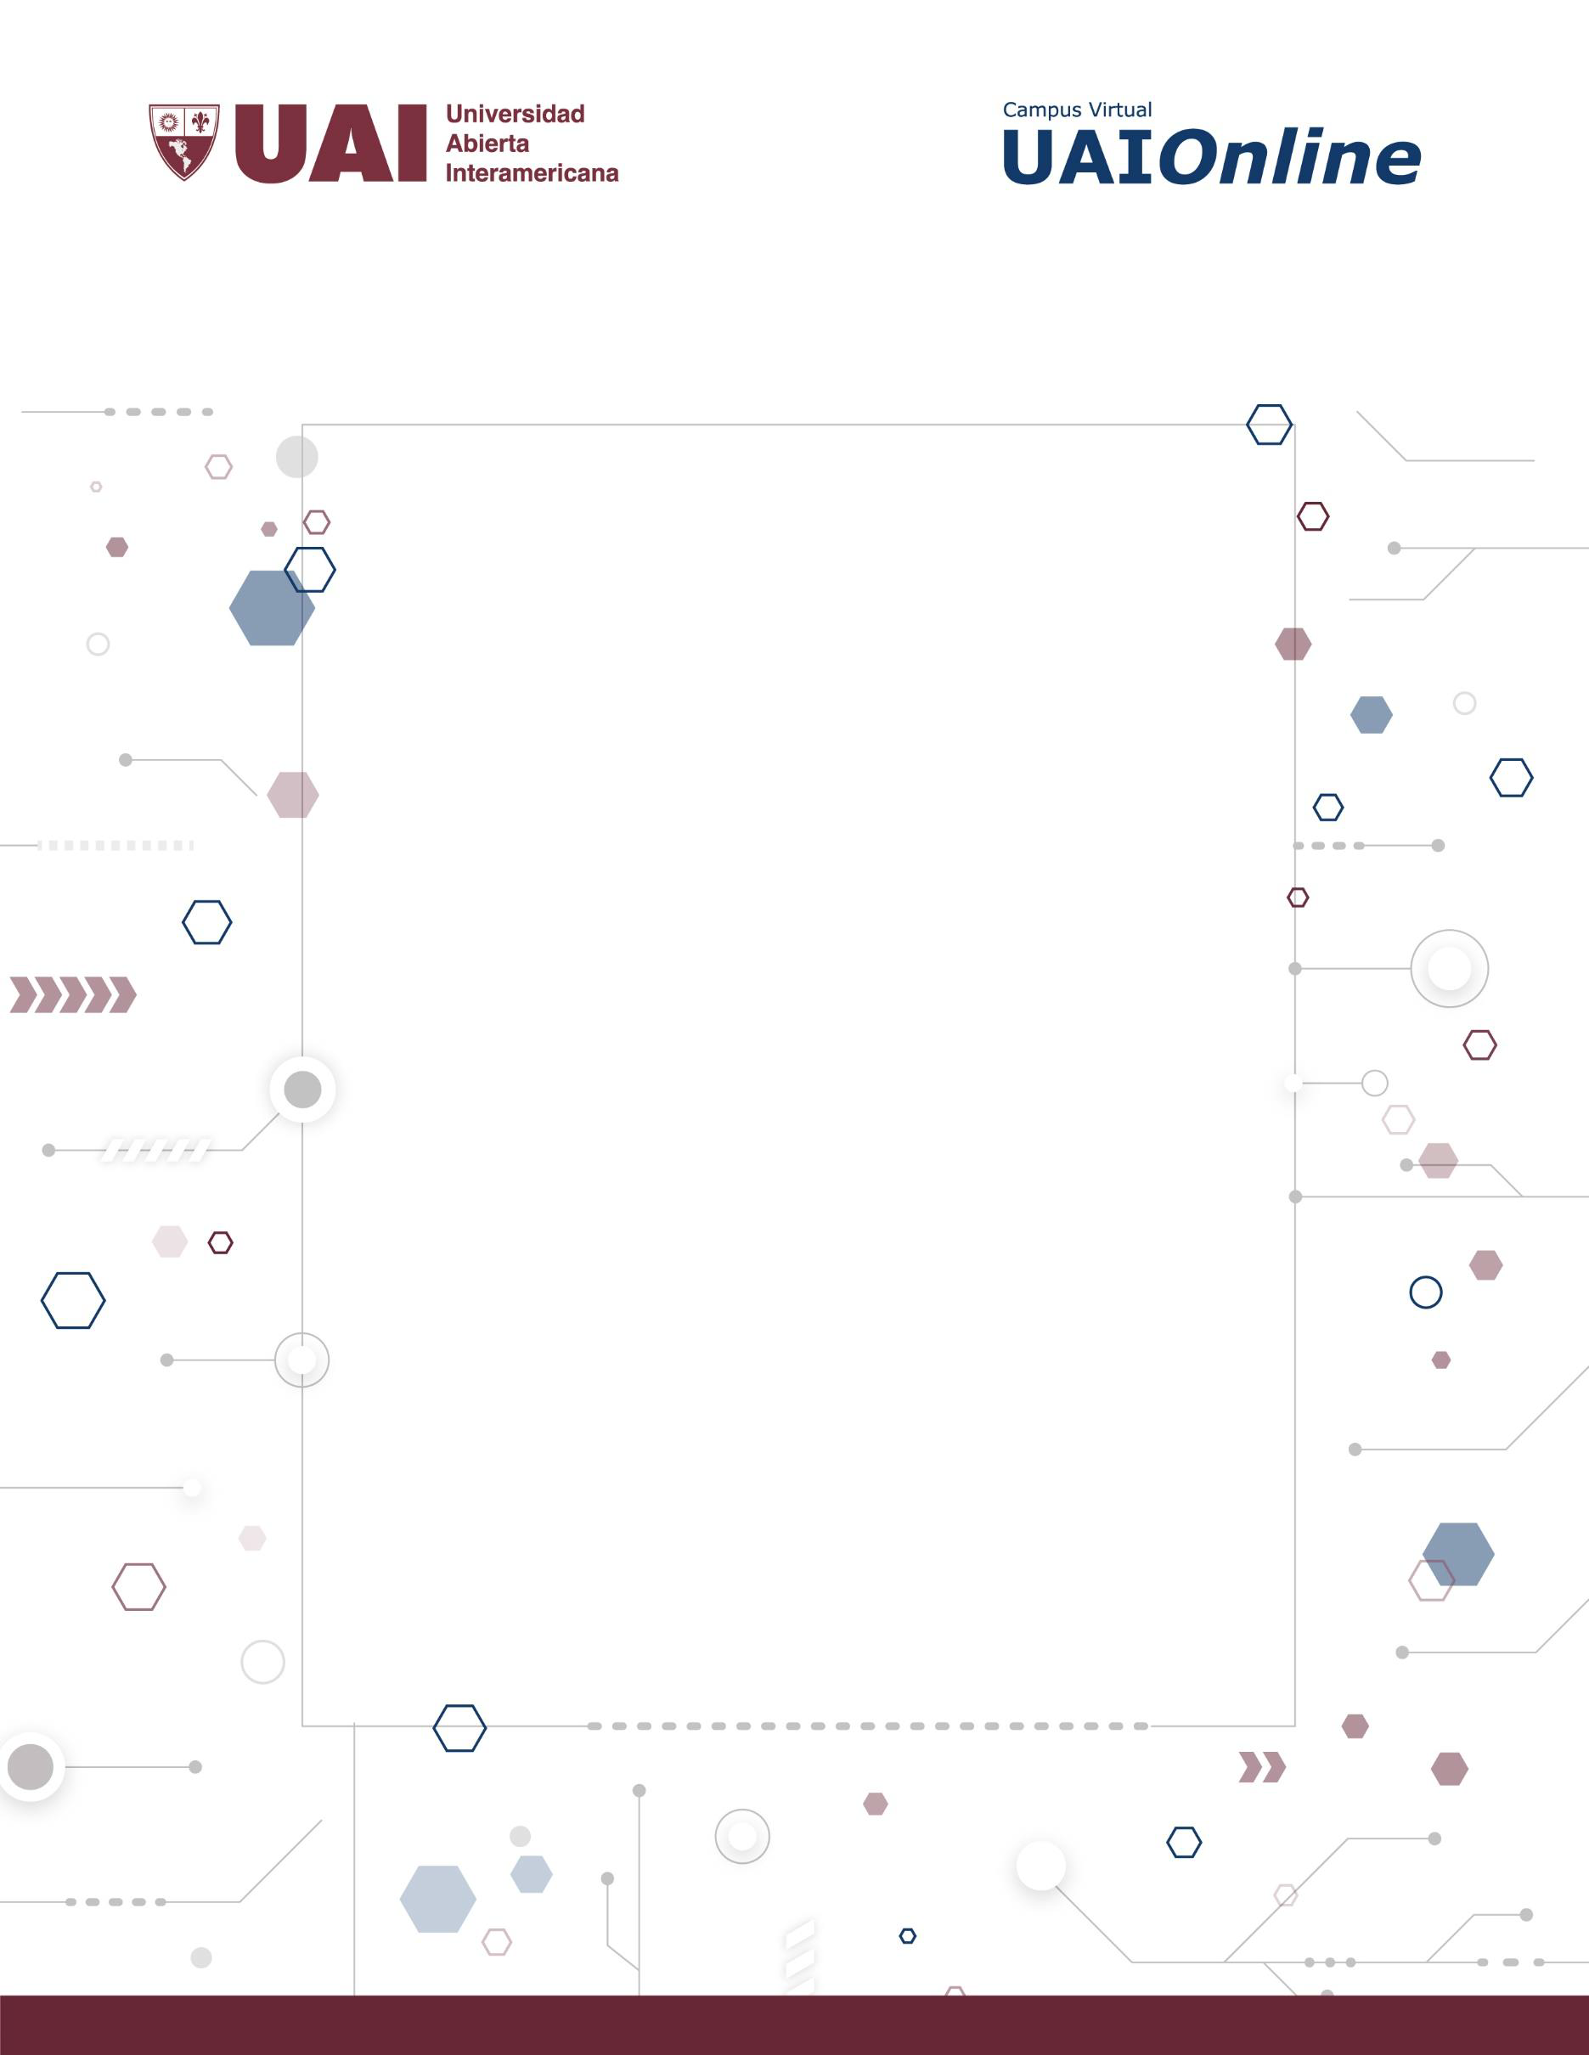

**METODOLOGÍA DE DESARROLLO DE** **SISTEMAS II**

GUÍA DE APRENDIZAJE 2.1 CASOS DE USO Y REQUISITOS

**UNIDAD 2** 

**HERRAMIENTAS DE MODELADO DEL ANÁLISIS Y DISEÑO ORIENTADO A OBJETOS.**

**2020**

**Autor de contenidos:**

Carlos Neil



**OBJETIVOS**

Comprender el concepto de Requisitos funcionales y el concepto de casos de uso y poder relacionarlos.

**PALABRAS CLAVE**

**REQUISITOS, CASOS DE USO, FUNCIONALES, NO FUNCIONALES, ELICITACIÓN.**

**PREGUNTAS**

1. ¿Qué es y para que se utiliza la Ingeniería de Requisitos?

2. ¿Qué es un requisito de software? ¿Cuáles son las características deseables? 3. ¿Qué es la Elicitación?

4. ¿Porque es necesaria la Elicitación?

5. Investigue y Explique la técnica de Elicitación, Brainstorming.

6. ¿Cuál es la diferencia entre la técnica Brainstorming y Prototipos? Investigar. 7. Mencione al menos 4 problemas para la identificación de requisitos.

8. Definir y explicar los tipos de Requisitos que conozca.

9. ¿Cuál es la relación entre los tipos de requisitos: usuarios y funcionales?

10. ¿Qué tipo de requisito debe ser considerado de mayor importancia?

11. Indique 3 ejemplos de cada tipo de requisito.

12. ¿Cuáles son los posibles actores en la Ingeniería de Requisitos?

13. ¿Cómo relacionaría los requisitos con los Casos de Uso?

14. ¿Cuál es el objetivo de realizar el diagrama de contexto?

15. Relacione el tema Casos de Usos y Escenarios.

16. Relacione el tema Casos de Usos y Colaboraciones.

17. Explique qué significa Asociación en Casos de Usos.

18. Diferencias entre la relación Include y Extend.

19. Explique qué significa Generalización en Casos de Usos.

20. Desarrolle 2 casos de ejemplo de Casos de Uso con problemas frecuentes.



MSD 2 / UNIDAD 2.1 / Pág.2



**EJERCICIOS**

A partir de la especificación del sistema “ATM-Simulation Example” resuelva:

1. Explique en sus propias palabras el comportamiento esperado para la siguiente

funcionalidad del ejemplo:

a. Se prende y apaga el cajero automático.

b. Control de lectura correcta de tarjeta y validación del ingreso de PIN.

c. Llevar a cabo operaciones de depósito, transferencia, consulta de saldo, y

extracción (incluyendo la interacción con el sistema del banco e impresión del ticket).

d. Manejo de situaciones de error y excepciones (por ejemplo, mencionar ante

qué situaciones se muestran aviso de errores por pantalla).

2. Describir los requisitos que encuentren dentro de la especificación

3. Realizar un modelo con Enterprise Architect

4. Identificar de que tipo es cada uno.

5. Realizar el modelo de casos de uso, en base a los requisitos funcionales.

**ATM SIMULATION EXAMPLE**

**REQUIREMENT SPECIFICATION**

The software to be designed will control a simulated automated teller machine (ATM) having a   
magnetic stripe reader for reading an ATM card, a customer console (keyboard and display) for   
interaction with the customer, a slot for depositing envelopes, a dispenser for cash (in multiples of

$20), a printer for printing customer receipts, and a key-operated switch to allow an operator to start

or stop the machine. The ATM will communicate with the bank's computer over an appropriate   
communication link. (The software on the latter is not part of the requirements for this problem.)

The ATM will service one customer at a time. A customer will be required to insert an ATM card and   
enter a personal identification number (PIN) - both of which will be sent to the bank for validation as   
part of each transaction. The customer will then be able to perform one or more transactions. The card will be retained in the machine until the customer indicates that he/she desires no further

transactions, at which point it will be returned - except as noted below.

The ATM must be able to provide the following services to the customer:

1. A customer must be able to make a cash withdrawal from any suitable account linked to the

card, in multiples of $20.00. Approval must be obtained from the bank before cash is   
dispensed.

2. A customer must be able to make a deposit to any account linked to the card, consisting of

cash and/or checks in an envelope. The customer will enter the amount of the deposit into the

ATM, subject to manual verification when the envelope is removed from the machine by an   
operator. Approval must be obtained from the bank before physically accepting the envelope.



MSD 2 / UNIDAD 2.1 / Pág.3



3. A customer must be able to make a transfer of money between any two accounts linked to the

card.

4. A customer must be able to make a balance inquiry of any account linked to the card.

A customer must be able to abort a transaction in progress by pressing the Cancel key instead of   
responding to a request from the machine.

The ATM will communicate each transaction to the bank and obtain verification that it was   
allowed by the bank. Ordinarily, a transaction will be considered complete by the bank once it ATM   
Simulation Example AG Software Engineering: Processes and Measurement has been approved. In the

case of a deposit, a second message will be sent to the bank indicating that the customer has deposited the envelope. (If the customer fails to deposit the envelope within the timeout period, or presses

cancel instead, no second message will be sent to the bank and the deposit will not be credited to the   
customer.)

If the bank determines that the customer's PIN is invalid, the customer will be required to   
reenter the PIN before a transaction can proceed. If the customer is unable to successfully enter the

PIN after three tries, the card will be permanently retained by the machine, and the   
customer will have to contact the bank to get it back.

If a transaction fails for any reason other than an invalid PIN, the ATM will display an   
explanation of the problem, and will then ask the customer whether he/she wants to do another

transaction. The ATM will provide the customer with a printed receipt for each successful transaction,   
showing the date, time, machine location, type of transaction, account(s), amount, and ending and   
available balance(s) of the affected account ("to" account for transfers).

The ATM will have a key-operated switch that will allow an operator to start and stop the   
servicing of customers. After turning the switch to the "on" position, the operator will be

required to verify and enter the total cash on hand. The machine can only be turned off when it is not servicing a customer. When the switch is moved to the "off" position, the machine will

shut down, so that the operator may remove deposit envelopes and reload the machine with

cash, blank receipts, etc.

The ATM will also maintain an internal log of transactions to facilitate resolving ambiguities   
arising from a hardware failure in the middle of a transaction. Entries will be made in the log when the

ATM is started up and shut down, for each message sent to the Bank (along with the response back, if   
one is expected), for the dispensing of cash, and for the receiving of an envelope. Log entries may   
contain card numbers and dollar amounts, but for security will never contain a PIN.



MSD 2 / UNIDAD 2.1 / Pág.4